Methicillin-Resistant *Staphylococcus aureus* inhibited by Photodynamic Antimicrobial Therapy

Anna Martinez1,2A. Nicholas Nolan2A, Heather Durkee2A, Alejandro Arboleda2A, Nidhi Relhan Batra2A, Mariela C. Aguilar2A, Cornelis Rowaan2A, Alex Gonzalez2A, Guillermo Amescua2B, Harry W. Flynn Jr2B, Darlene Miller2B,2C, Jean-Marie Parel2A

1Massachusetts Institute of Technology, Cambridge, MA.

2AOphthalmic Biophysics Center, 2BAnne Bates Leach Eye Hospital, 2COcular Microbiology Laboratory, Department of Ophthalmology, Bascom Palmer Eye Institute, University of Miami Miller School of Medicine, Miami, FL.

**Introduction:** Methicillin-Resistant *Staphylococcus aureus* (MRSA) keratitis is a serious corneal infection which may result in vision loss. Currently available topical antibiotics are increasingly resistant to both healthcare (SCCmec II, USA 100) and community (SCCmec IV, US300) associated corneal isolates. An emerging alternate treatment is photodynamic antimicrobial therapy (PDAT). In this *in vitro* study, the efficacy of rose bengal (RB) and riboflavin (Ribo) mediated PDAT for the inhibition of healthcare and community-acquired MRSA strains is assessed.

**Materials and Methods:** MRSA SCCmec II and IV strains were isolated from the corneal scraping of patients with confirmed bacterial keratitis. Twenty-four hours prior to experimentation, parent cultures were plated on blood agar. Next, a culture of MRSA was transferred into tryptic soy broth and adjusted to a concentration of 1.5x108 colony forming units per mL (cfu/mL). Serial dilutions were prepared for both rose bengal (0.2%, 0.1%, 0.05%, 0.025%, 0.0125%) and riboflavin (0.2%, 0.1%, 0.05%) solutions. The MRSA suspension was diluted to a concentration of 1.5x106 cfu/mL with the respective photosensitizing solutions and 1mL aliquots were inoculated in triplicate onto blood agar plates. The eight groups for each concentration were: (1) Control (high purity sterile water) (2) UV-A irradiation (375 nm) (3) Ribo only (4) Ribo + UV-A (5) RB only (6) RB + Green LED (518 nm) (7) RB + 15 min ambient light (8) RB + 30 min ambient light. The UV-A and Green lights are custom built 6 mW/cm2 LED sources. Plates were either exposed to UV-A (Ribo) or Green LED (RB) irradiation for 15 minutes. All plates were immediately placed upside down, wrapped in foil, and placed in an incubator at 30°C. Plates were photographed after 48 hours and 7 days.

**Results and Discussion:** Both strains of MRSA were inhibited by 0.2% Ribo with UV-A irradiation in a small central zone; however not within the entire area of the irradiation source. Rose bengal of all concentrations (0.2%, 0.1%, 0.05%, 0.025%, and 0.0125%) with ambient and green light light conditions demonstrated nearly 100% inhibition. Rose bengal was more effective than riboflavin at inhibiting MRSA growth. The healthcare-acquired and community-acquired MRSA strains demonstrated different inhibitory efficacy to the RB PDAT.

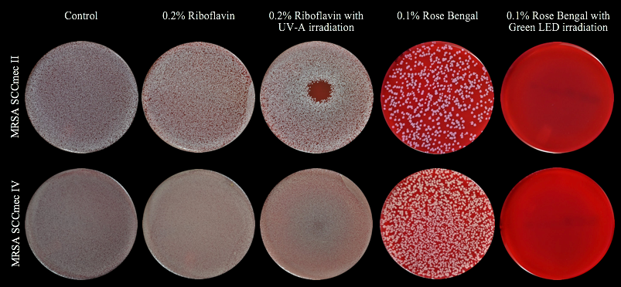

**Figure 1.** Results from 0.2% Ribo and 0.1% RB mediated PDAT for SCCmec II and IV MRSA strains at 48 hours.

**Conclusions:** Rose bengal strips of 1.0% concentration are clinically used to detect conjunctival epithelial defects. This study demonstrates MRSA can be inhibited even with a lower concentration of RB. RB PDAT could be an excellent adjunct treatment for MRSA keratitis. Studies are currently being performed to determine the different responses to the treatment.

**Acknowledgments:** The authors are grateful for the scientific and technical support provided by: Carolina de Freitas, Juan Silgado, Kelly Mote, Karam Alawa, Francisco Halili, and Victor Hernandez. Support: The Robson Foundation, Florida Lions Eye Bank, Drs. KR Olsen and ME Hildebrandt, Dr. Raksha Urs and Aaron Furtado, Center Grant P30EY14801, Research to Prevent Blindness, and Henri and Flore Lesieur Foundation (JMP).